Kernel Liniar:

Acuratete: 83.04%

MSE: 0.1749

Marime set de antrenare: 36010 (70%)

Nr. iteratii: 10mil (nr. maxim de iteratii)

Nr. vectori suport: 603

Datele nu sunt liniar separabile, asa ca se incearca sa se ajunga la un optim, dar se opreste la max. iterations.

Matricea de confuzie test:

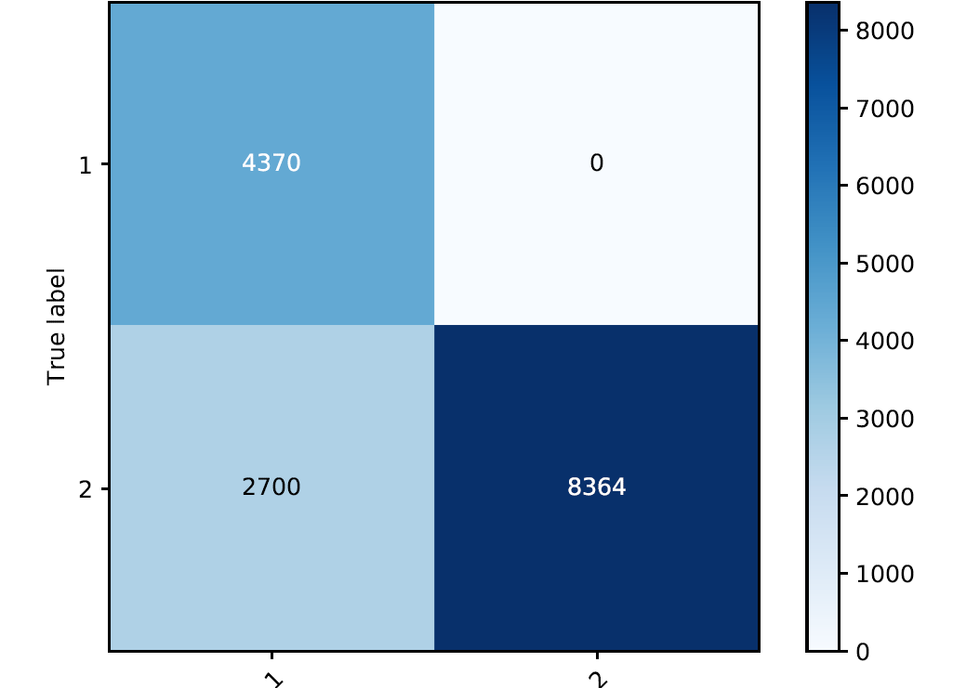

Matricea de confuzie train:

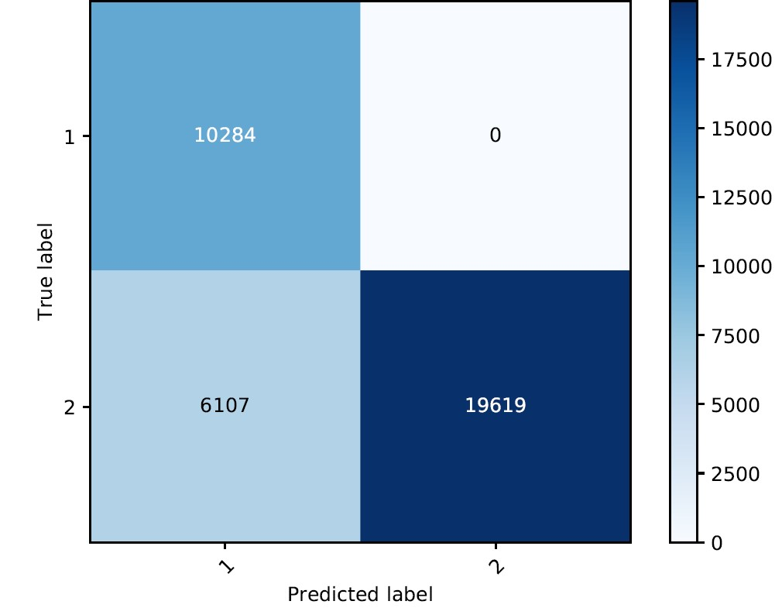

Kernel Polinomial:

Nr. iteratii = 10mil (maxim)

|  |  |  |  |  |  |  |
| --- | --- | --- | --- | --- | --- | --- |
| Acuratete | MSE | Marime set de antrenare | Nr. vectori support | Gamma | Grad | Coef0 |
| 93.73% | 0.0626 | 36010 | 1177 | 0.005 | 2 | 0 |
| 99.33% | 0.0066 | 36010 | 559 | 0.005 | 2 | 1 |
| 99.28% | 0.0071 | 36010 | 566 | 0.005 | 2 | 2 |
| 89.98% | 0.1035 | 36010 | 523 | 0.05 | 2 | 0 |
| 99.3% | 0.0069 | 36010 | 328 | 0.05 | 2 | 1 |
| 98.71% | 0.0128 | 36010 | 279 | 0.05 | 2 | 2 |
| 75.89% | 0.2410 | 36010 | 347 | 0.005 | 3 | 0 |
| 99% | 0.0099 | 36010 | 233 | 0.005 | 3 | 1 |
| 94.17% | 0.0582 | 36010 | 233 | 0.005 | 3 | 2 |
| 67.75% | 0.3224 | 36010 | 320 | 0.05 | 3 | 0 |
| 97.51% | 0.0248 | 36010 | 238 | 0.05 | 3 | 1 |
| 99.24% | 0.0075 | 36010 | 244 | 0.05 | 3 | 2 |

Matricea de confuzie test:

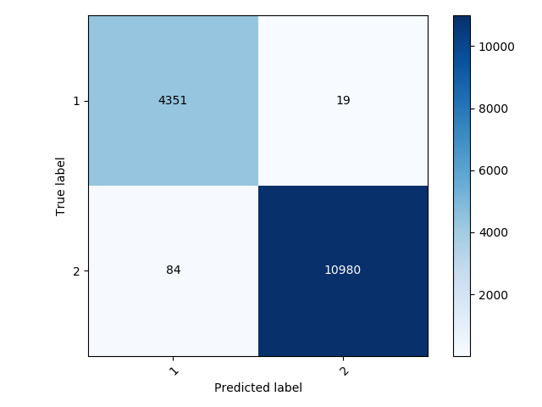

Matricea de confuzie train:

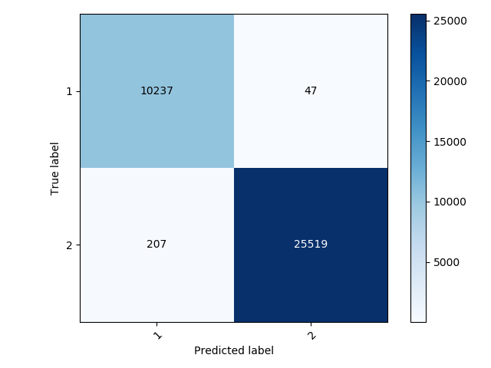

Eroare in functie de gamma:

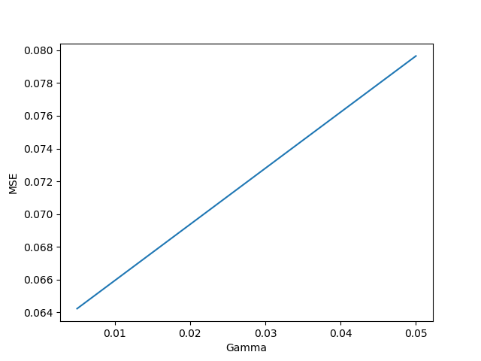

Pentru un gamma cat mai mic, se obtine cea mai mica eroare.

Eroare in functie de grad:

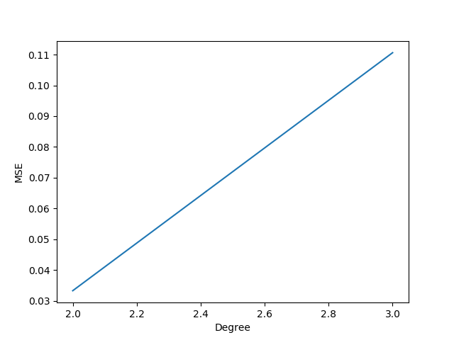

Pentru un polinom cu grad mai mare, se obtin in medie erori mai mari.

Eroare in functie de coef0:

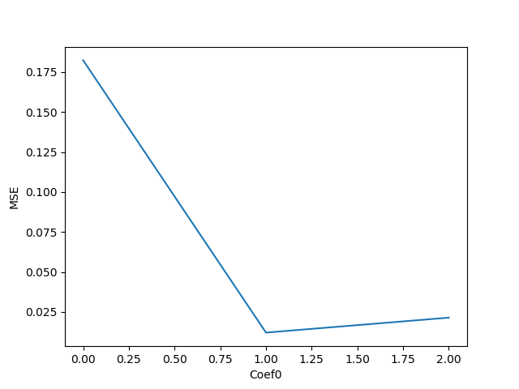

Se observa ca pentru coef0 = 1, avem cea mai mica eroare medie.

Kernel Gaussian:

|  |  |  |  |  |  |
| --- | --- | --- | --- | --- | --- |
| Acuratete | MSE | Marime set de date | Nr. iteratii | Nr. vectori support | Gamma |
| 99.81% | 0.0018 | 36010 | 7528 | 2716 | 0.005 |
| 99.77% | 0.0022 | 36010 | 55869 | 15046 | 0.05 |
| 97.99% | 0.02 | 36010 | 92351 | 32092 | 0.25 |
| 92.51% | 0.0748 | 36010 | 75934 | 35579 | 0.5 |
| 71.93% | 0.2806 | 36010 | 72227 | 36010 | 1.5 |
| 71.66% | 0.2833 | 36010 | 96653 | 36010 | 5 |
| 71.66% | 0.2833 | 36010 | 90425 | 36010 | 20 |
| 71.66% | 0.2833 | 36010 | 89254 | 36010 | 40 |

Matricea de confuzie test:

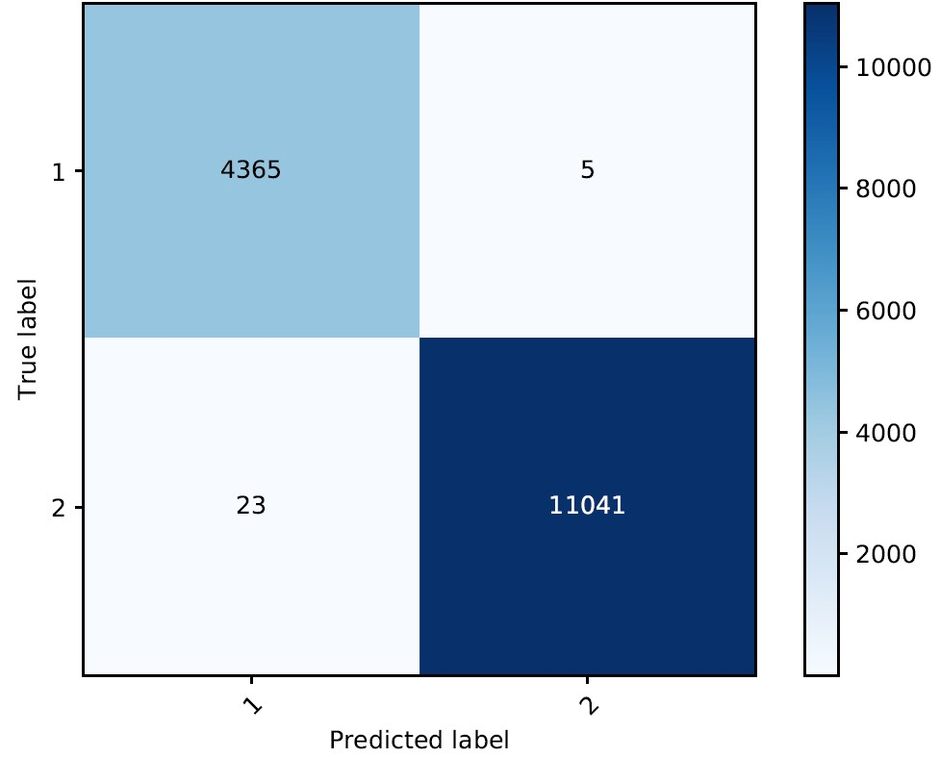

Matricea de confuzie train:

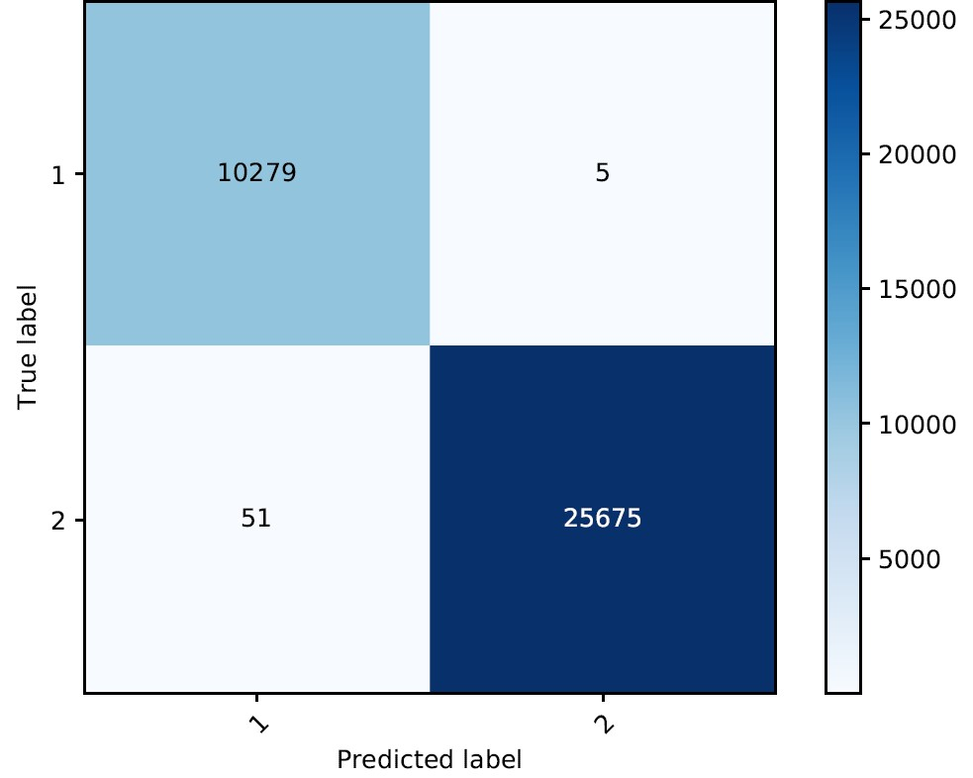

Eroare in functie de gamma:

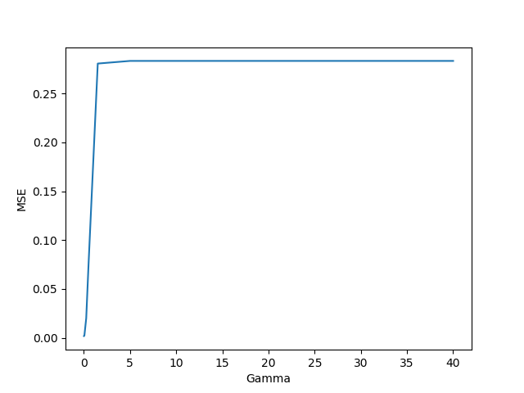

La fel si aici, pentru gama cat mai mic, obtinem erori mai mici.

Kernel Sigmoid:

|  |  |  |  |  |  |  |
| --- | --- | --- | --- | --- | --- | --- |
| Acuratete | MSE | Marime set de date | Nr. iteratii | Nr. vectori support | Gamma | Coef0 |
| 46.76% | 0.5323 | 36010 | 10239 | 20476 | 0.005 | 0.0 |
| 55.24% | 0.4475 | 36010 | 10285 | 20568 | 0.005 | 1.0 |
| 66.12% | 0.3387 | 36010 | 10285 | 20568 | 0.005 | 2.0 |
| 65.14% | 0.3485 | 36010 | 10285 | 10285 | 0.05 | 0.0 |
| 68.21% | 0.3178 | 36010 | 10285 | 20568 | 0.05 | 1.0 |
| 69.71% | 0.3028 | 36010 | 10284 | 20568 | 0.05 | 2.0 |
| 68.74% | 0.3125 | 36010 | 10284 | 20568 | 0.5 | 0.0 |
| 68.76% | 0.3123 | 36010 | 10284 | 20568 | 0.5 | 1.0 |
| 70.28% | 0.2971 | 36010 | 10284 | 20568 | 0.5 | 2.0 |
| 68.76% | 0.3123 | 36010 | 10284 | 20568 | 5 | 0.0 |
| 68.76% | 0.312 | 36010 | 10284 | 20568 | 5 | 1.0 |
| 70.34% | 0.2965 | 36010 | 10284 | 20568 | 5 | 2.0 |

Matricea de confuzie test:

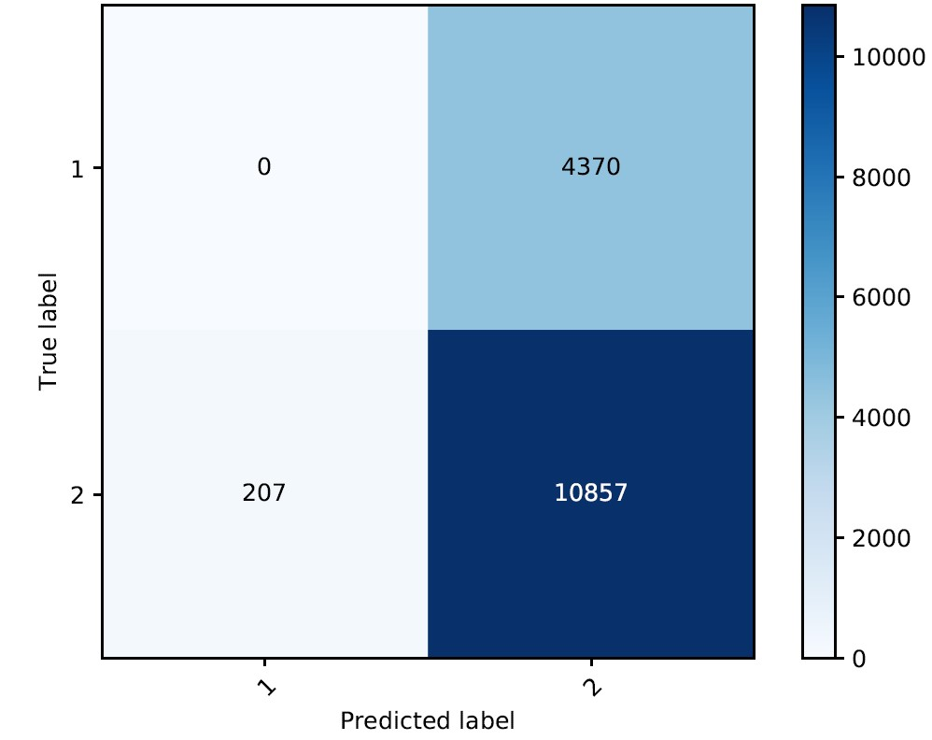

Matricea de confuzie train:

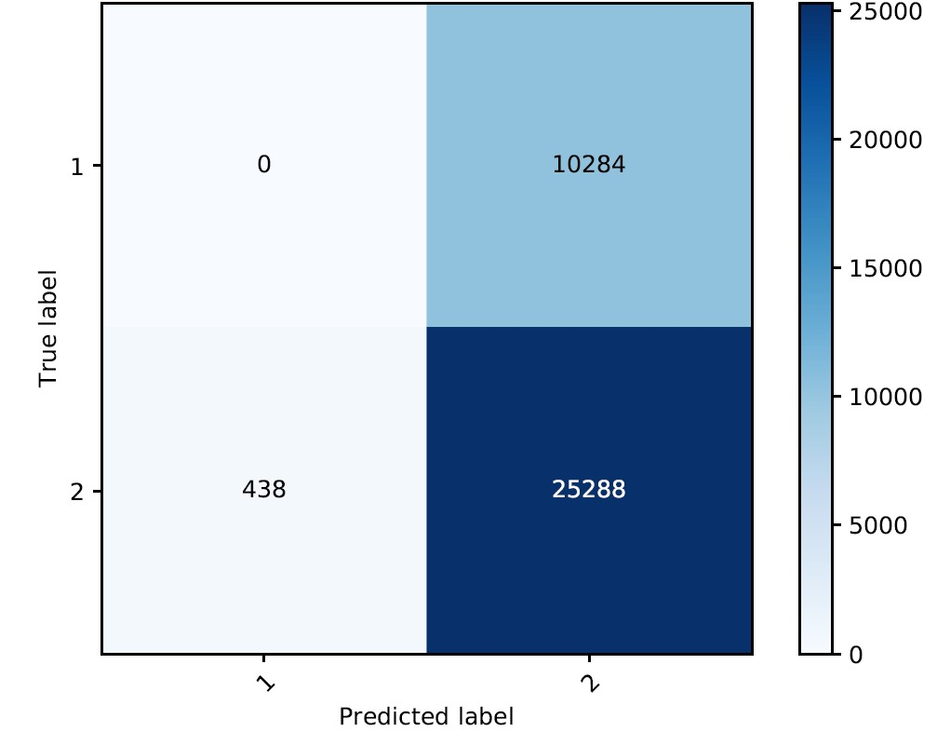

Eroare in functie de gamma:

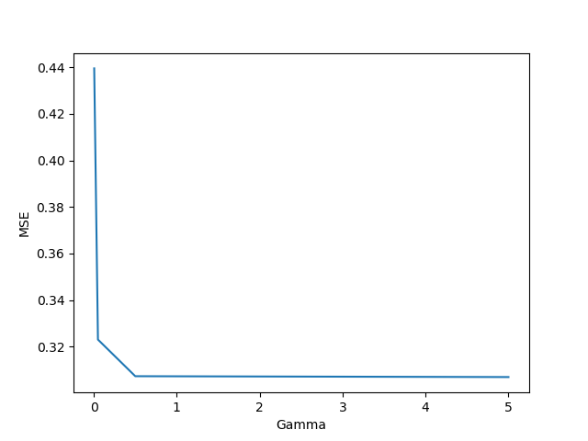

Pentru gamma cat mai mare, obtinem erori mai mici.

Eroare in functie de coef0:

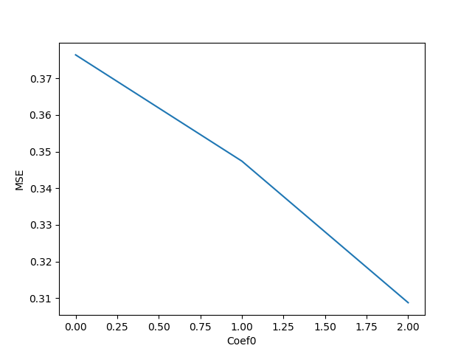

Pentru coef0 cat mai mare, obtinem erori mai mici.